Church at Canyon Creek Check-In Application User Guide

**2009-2015**

Robert Smith

Church at Canyon Creek

1/28/2015

Table of Contents



Application Description 6

Menus 6

File Menu 6

Options Menu 6

Help Menu 6

Dialogs 7

The Options Dialog 7

Check-In Screens 8

Children Check-In 9

Screen description 9

Checking in a child to assigned class 9

Limiting check-In for special events 9

Reprinting name tag labels 10

Refreshing data within the screen 10

Preschool Check-In 11

Screen description 11

Checking in a family 11

Editing information for a family member 12

Refreshing data within the screen 12

MOPS Check-In 13

Screen description 13

Checking in a family 13

Editing information for a family member 14

Refreshing data within the screen 14

Name Tag Label Formats 15

Regular Name Tag Label 15

Name Tag Label for Person with Special Conditions 15

Name Tag Label for Teacher 16

Administration Screens 17

Attendance Administration 18

Screen description 18

Viewing attendance records for a department 18

Deleting attendance records 18

Reprinting a name tag 19

Refreshing data within the screen 19

Class Movement 20

Screen description 20

Moving all members of a class within department or to new department 20

Moving selected members of a class within department or to new department 20

Refreshing data within the screen 21

Classes Administration 22

Screen description 22

Viewing classes within a department 22

Adding a class to a department 22

Updating a class within a department 23

Deleting a class from a department 23

Refreshing data within the screen 23

Departments Administration 24

Screen description 24

Viewing departments 24

Adding a department 24

Updating a department 25

Deleting a department 25

Assigning classes to a department 25

Refreshing data within the screen 26

Family Quick Entry 27

Screen description 27

Adding a person to the family members list 27

Edit a person in the family members list 27

Saving family members 28

Saving and checking in family members 28

Refreshing data within the screen 28

People Administration 29

Screen description 29

Viewing class members 29

Adding a new class member 29

Updating a class member 30

Deleting a class member 30

Moving a class member to a different class 31

Viewing a person’s family members 31

Adding a person to an existing family 31

Deleting a person from an existing family 31

Updating family roles for an existing family 32

Refreshing data within the screen 32

Reports Administration 33

Screen description 33

Reporting on who attended class during a particular date range 33

Reporting on how many people attended a class during a particular date range 34

Reporting on the attendance record for a particular person 34

Saving a report as a .XPS (XML Paper Specification) document 35

Printing a report 35

Refreshing data within the screen 36

Teachers Administration 37

Screen description 37

Adding an adult as a teacher of a class 37

Removing an adult as a teacher from a class 37

Printing teacher labels for a class 38

Printing teacher labels for a department (all classes) 38

Refreshing data within the screen 38

Technical Information 39

Application Installation 39

Application Update 41

Application Removal 42

The CACCCheckIn Database 43

Technology Used 44

Source Code Repository 44

Physical Layout Diagram 45

# Application Description

The Church at Canyon Creek Check-In application was designed to provide check-in functionality for the Preschool, MOPS and Children’s departments. Each department has a check-in screen which allows attendees to be checked in and name tag labels to be printed. There are also administrative screens which allow the various departments, classes, people and attendance records to be administered.

# Menus

The application menu is located at the top of the application as shown in the following screenshot.

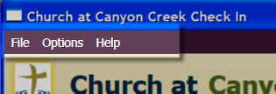

## File Menu

The File menu has the following sub-menu items:

* Exit – Select this menu item to close the application

## Options Menu

The Options menu has no sub-menu items. Clicking the Options menu item will open the Options dialog.

## Help Menu

The File menu has the following sub-menu items:

* About – Select this menu item to open the About dialog. The About dialog just shows some basic information about the application.

# Dialogs

## The Options Dialog

The Options dialog is used to configure the Check-In application for the appropriate department and the correct label printer.

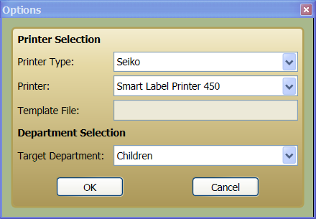

The Printer Selection section is used to configure the name-tag label printer that is currently being used at the Check-In station. The following settings are related to the label printer.

* **Printer Type**: Can be either “Dymo” or “Seiko”. The Check-In application only supports these two printer brands at this time.
* **Printer**: The choices here are based on the printer type selection. When “Dymo” is the printer type, “Dymo” printers are available for selection. When “Seiko” is the printer type, “Seiko” printers are available for selection. The printer currently installed at the check-in station should be selected here.
* **Template File**: When “Dymo” is the printer type, there is a template file which contains the template for the name-tag label. This value defaults to the name-tag template which is included with the application.

The Department Selection section is used to configure the Check-In application for the appropriate department where the station is primarily used.

* **Target Department**: The available departments are either “Children”, “MOPS” or “Preschool”. The target department selection will affect which check-in screen is shown and which department is used as the default value on the various administration screens.

# Check-In Screens

The Check-In screens which will be shown are different based on the currently selected department. These different screens and their usage are documented in this section.

* Children Check-In
* Preschool Check-In
* MOPS Check-In

## Children Check-In

### Screen description

The Children check-in screen is shown whenever the Check-In application is configured for the “Children” department. This check-in screen is used to check in children in the “Children” department and adults who are assigned as teachers in the department.

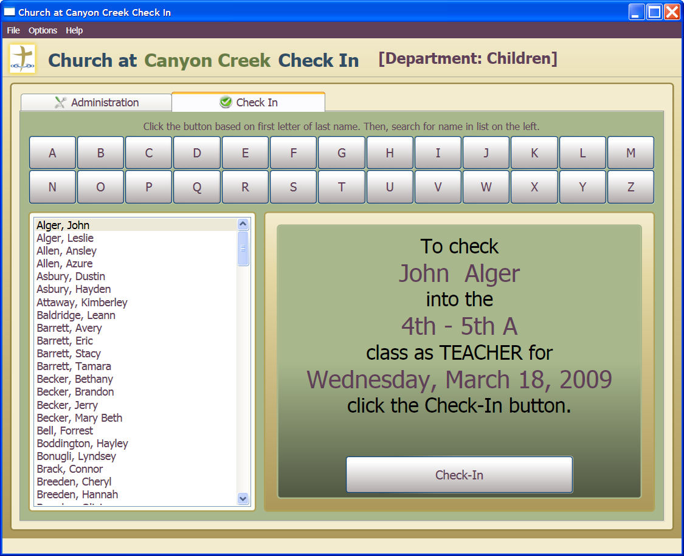

### Checking in a child to assigned class

1. The user clicks the buttons A-Z based on the first letter of their last name. Upon doing this, the list of names in the list will be filtered by that last name.
2. The user then selects their name from the list. The panel on the right will change to reflect the currently selected user and which class they will be checked into if the Check-In button is clicked.
3. If the correct user is selected and the user wants to check in; the user clicks the Check-In button.
4. The child or teacher will be checked in to the assigned class and a name tag label will be printed to the assigned printer.

### Limiting check-In for special events

Normally, the check-in screen checks in users to the assigned classes in the Children’s department. However, the screen can be configured to allow check in for special events like “Extreme Kids”.

1. To do this, the user presses <CTRL-L> on the keyboard. This will open the “Limit Check-In” panel.
2. To limit check in to a particular class or event, select the specific class or event from the combo-box and then click the “Limit Check-In” button. This will limit check in to the selected class or event and users will be checked into this event and not the normal assigned classes.
3. To remove the limit, the user presses <CTRL-L> on the keyboard again, selects the blank entry in the combo-box and clicks the “Limit Check-In” button. This will restore normal check in operation.

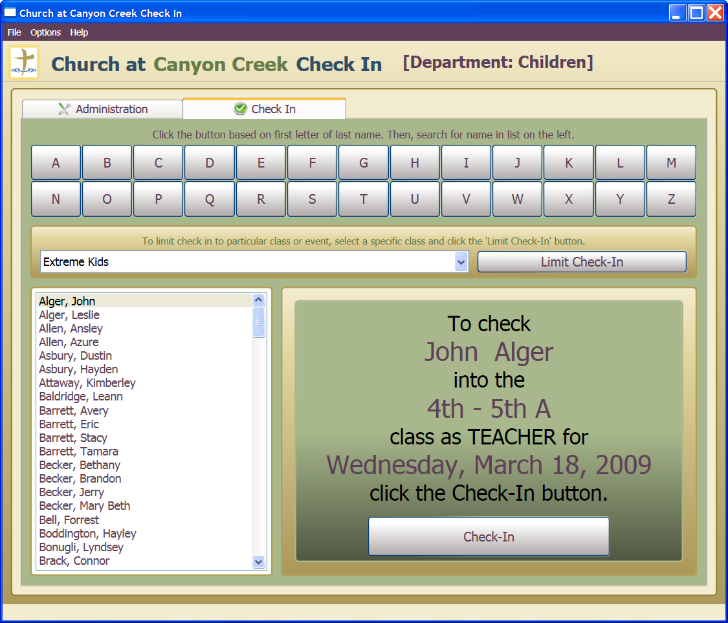

### Reprinting name tag labels

1. A child may need a name tag label reprinted for various reasons including losing the name tag or printer jamming or malfunctioning during check in.
2. If so, follow instructions for reprinting a name tag.

### Refreshing data within the screen

The Check-in application can be used at many different workstations at the same time and uses a shared database. Because of this, it is possible that a different user will add new information to the system that is not “seen” by the other applications by default. It is possible to retrieve this new data from the database into the current application by refreshing the current screen.

1. Press the <F5> key. This will refresh the data in the current screen using the latest data from the database.

## Preschool Check-In

### Screen description

The Preschool check-in screen is shown whenever the Check-In application is configured for the “Preschool” department. This check-in screen is used to check-in families with children in the “Preschool” department.

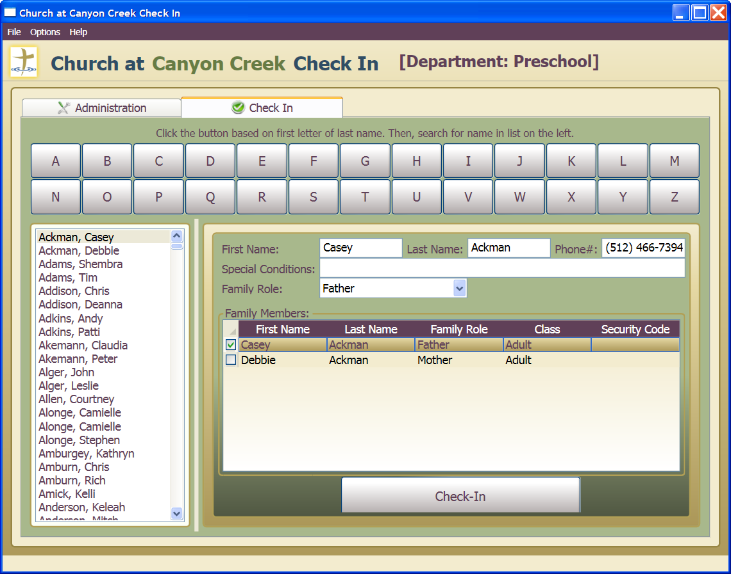

### Checking in a family

1. The user clicks the buttons A-Z based on the first letter of the last name of the adult family member. Upon doing this, the list of names in the list will be filtered by that last name.
2. The user then selects the adult name from the list. The panel on the right will change to reflect the currently selected family member along with other members of his/her family. Adults in the family and children in the “Preschool” department will be displayed in the “Family Members” data grid.
3. It is possible to check-in some members of the family now and other members later. Just click the check box next to the family members that are currently checking in. It is possible to click the upper-left corner of the data grid to quickly select all members of the family for check-in.

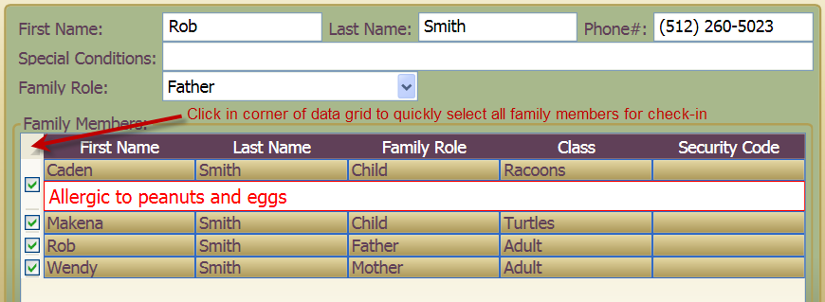

1. After appropriate check boxes are checked, the user clicks the “Check-In” button.
2. The selected children and adults will be checked in to their assigned classes and a name tag label will be printed to the assigned printer for each person. Each person in family checked in will receive the same security code.

**NOTE**: If only a partial group of people in the family are checked in, it is possible to come back later and check in the remaining members. They will receive the same security code as the other family members already checked in.

### Editing information for a family member

1. Information for the currently selected person can be updated if needed.
2. Select the desired person to edit from the “Family Members” data grid. This will cause information for that person to be displayed in the fields above the data grid.
3. Make any desired changes to the First Name, Last Name, Phone Number, Special Conditions or Family Role.
4. The changes to each field are saved as you move out of the field. For instance, if the user changes the First Name, the change will be saved once the user moves to a different field.

### Refreshing data within the screen

The Check-in application can be used at many different workstations at the same time and uses a shared database. Because of this, it is possible that a different user will add new information to the system that is not “seen” by the other applications by default. It is possible to retrieve this new data from the database into the current application by refreshing the current screen.

1. Press the <F5> key. This will refresh the data in the current screen using the latest data from the database.

## MOPS Check-In

### Screen description

The MOPS check-in screen is shown whenever the Check-In application is configured for the “MOPS” department. This check-in screen is used to check-in families with children in the “MOPS” department.

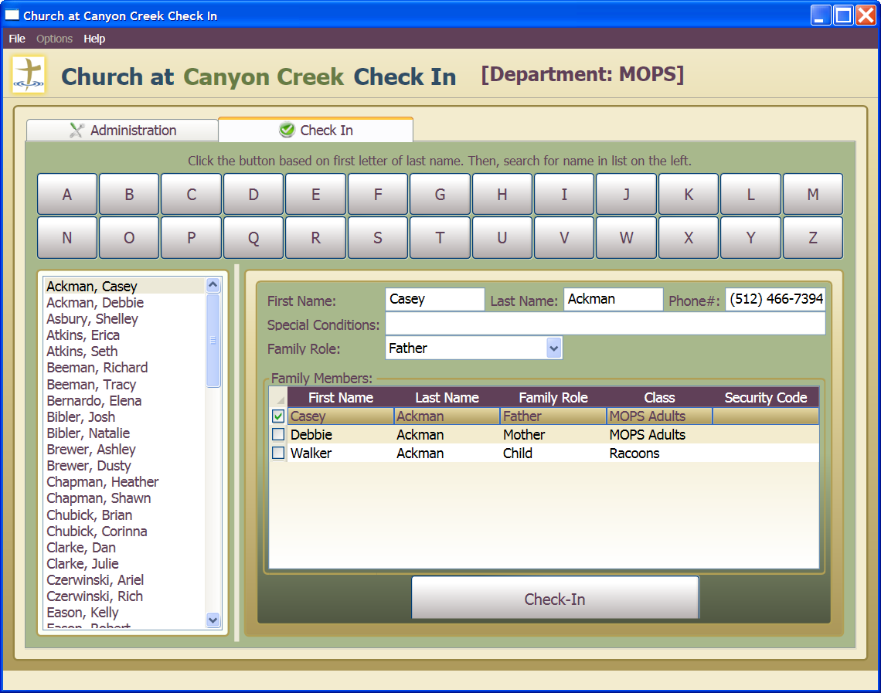

### Checking in a family

1. The user clicks the buttons A-Z based on the first letter of the last name of the adult family member. Upon doing this, the list of names in the list will be filtered by that last name.
2. The user then selects the adult name from the list. The panel on the right will change to reflect the currently selected family member along with other members of his/her family. Adults in the family and children in the “MOPS” department will be displayed in the “Family Members” data grid.
3. It is possible to check-in some members of the family now and other members later. Just click the check box next to the family members that are currently checking in. It is possible to click the upper-left corner of the data grid to quickly select all members of the family for check-in.



1. After appropriate check boxes are checked, the user clicks the “Check-In” button.
2. The selected children and adults will be checked in to their assigned classes and a [name tag label](#Name Tag Label Formats) will be printed to the assigned printer for each person. Each person in family checked in will receive the same security code.

**NOTE**: If only a partial group of people in the family are checked in, it is possible to come back later and check in the remaining members. They will receive the same security code as the other family members already checked in.

### Editing information for a family member

1. Information for the currently selected person can be updated if needed.
2. Select the desired person to edit from the “Family Members” data grid. This will cause information for that person to be displayed in the fields above the data grid.
3. Make any desired changes to the First Name, Last Name, Phone Number, Special Conditions or Family Role.

The changes to each field are saved as you move out of the field. For instance, if the user changes the First Name, the change will be saved once the user moves to a different field.

### Refreshing data within the screen

The Check-in application can be used at many different workstations at the same time and uses a shared database. Because of this, it is possible that a different user will add new information to the system that is not “seen” by the other applications by default. It is possible to retrieve this new data from the database into the current application by refreshing the current screen.

1. Press the <F5> key. This will refresh the data in the current screen using the latest data from the database.

## Name Tag Label Formats

During the check-in process, name tab labels are printed. The name tag labels are formatted as described in this section.

### Regular Name Tag Label

The regular name tag label contains the name of the person checking in, the security code assigned to the person, the class name where person is assigned and the current date. The security code assigned will be the same for all family members. When a parent / guardian is picking up a child, they should present a name tag with the same security code as the child.

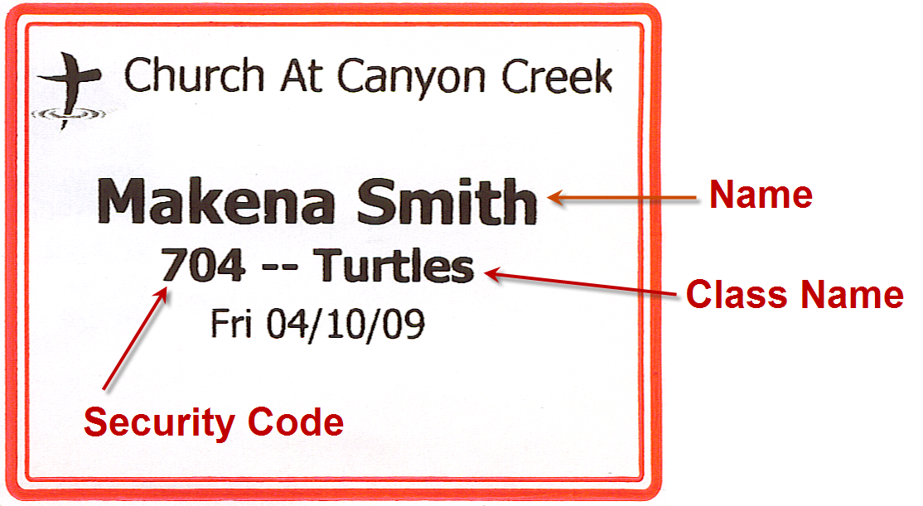

### Name Tag Label for Person with Special Conditions

The name tag for a person with special conditions is just like the regular label except that there is a line at bottom of label describing the special conditions for the person. These special conditions usually describe allergic reactions and such for a child.

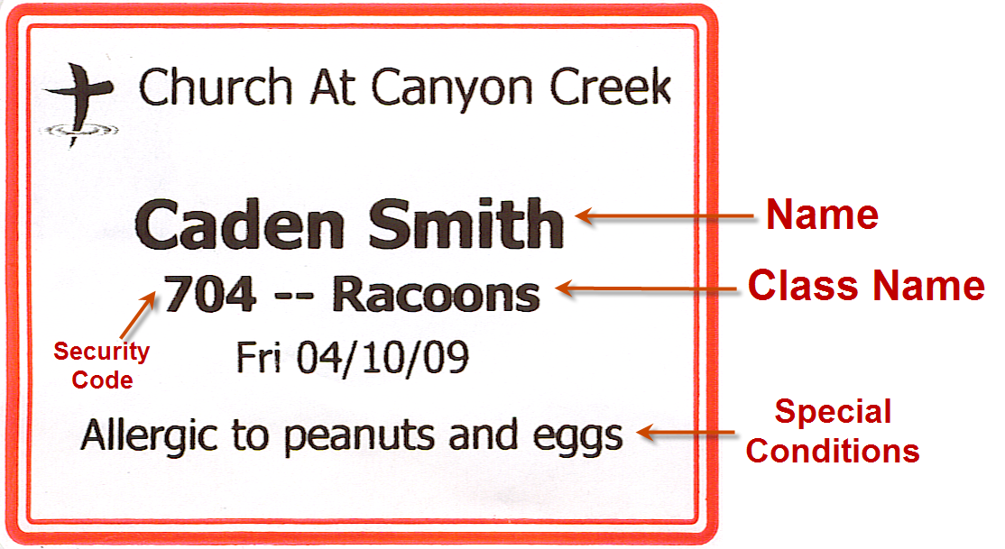

### Name Tag Label for Teacher

The name tag label for a teacher contains the teacher’s name, the class they are assigned to teach in, and the title of “Teacher”.

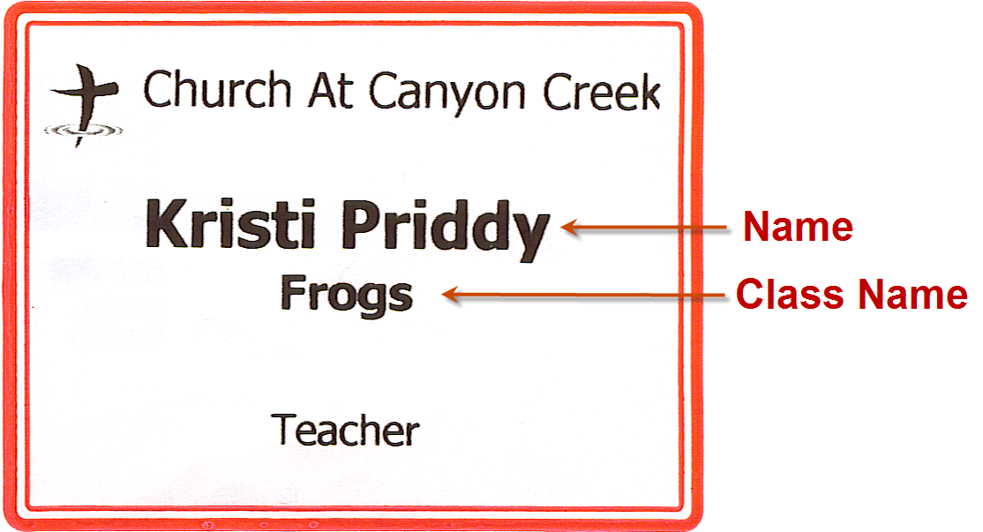

# Administration Screens

The Administration screens allow the user to administer various areas of the check-in application. These administrative actions include such things as viewing attendance records and creating reports from the attendance records, reprinting name tag labels, adding/editing/deleting people, assigning people to classes and moving people between classes. The administration screens are the same for every department. However, the default department selected for each screen will be based on the currently configured target department for the application.

WARNING: Be aware when modifying or deleting data in any of the administration screens to not affect people or information which may be used in a different department. This is particularly true in the People Administration screen where adults may be in the systems as teachers in different departments.

These different screens and their usage are documented in this section.

* Attendance Administration
* Class Movement
* Classes Administration
* Departments Administration
* Family Quick Entry
* People Administration
* Reports Administration
* Teachers Administration

## Attendance Administration

Screen description  
This screen can be used to view and delete attendance records and reprint name tags.

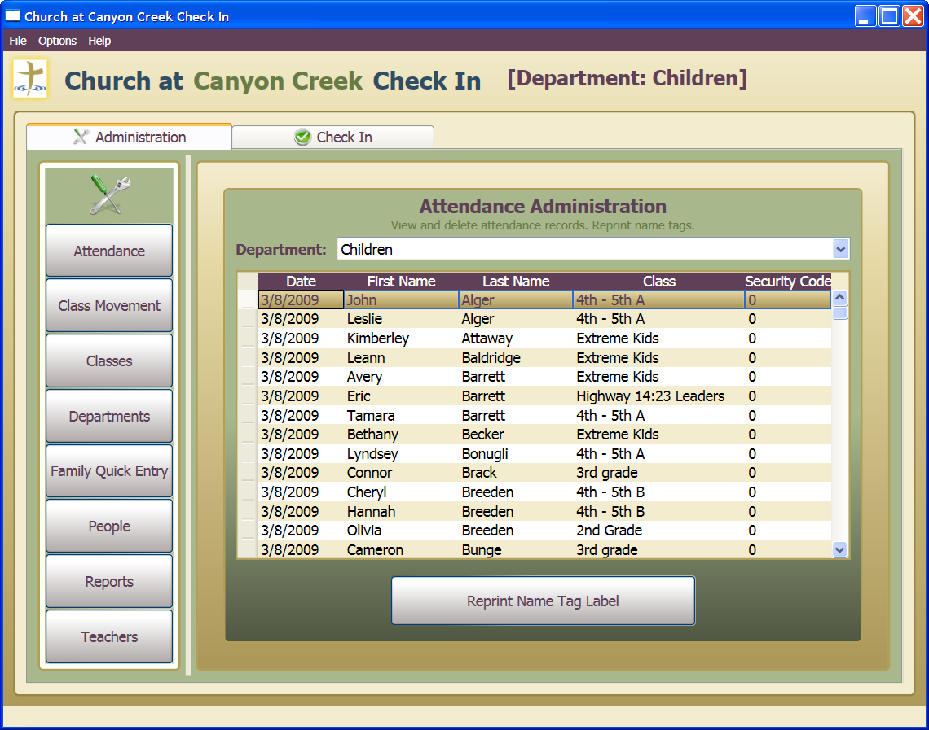

### Viewing attendance records for a department

1. Select the Department to view attendance records for. The Department combo box will default to the currently configured department for the application.
2. Attendance records for the selected department will be shown and sorted by Date in descending order. For attendance records on the same Date, records are sorted by Last Name and then First Name.
3. Attendance records can be resorted by clicking the column header of the column to sort by.

### Deleting attendance records

1. Select the Department for the attendance record that needs to be deleted. The Department combo box will default to the currently configured department for the application.
2. Attendance records for the selected department will be shown and sorted by Date in descending order. For attendance records on the same Date, records are sorted by Last Name and then First Name.
3. Locate the attendance record for the person that needs to be deleted.
4. Click the attendance record to delete and press the <DELETE> key. A confirmation dialog will be displayed.

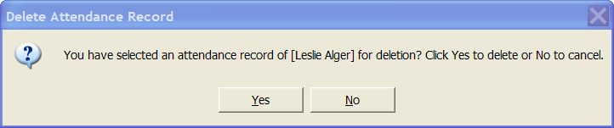

1. Click “Yes” button to delete the selected record or click “No” button to cancel deletion.

### Reprinting a name tag

1. Select the Department for the attendance record that needs to be deleted. The Department combo box will default to the currently configured department for the application.
2. Attendance records for the selected department will be shown and sorted by Date in descending order. For attendance records on the same Date, records are sorted by Last Name and then First Name.
3. Locate the attendance record for the person that needs a name tag reprinted.
4. Click the attendance record to reprint.
5. Press “Reprint Name Tag Label” button. The [name tag](#Name Tag Label Formats) matching the selected attendance record will be reprinted.

### Refreshing data within the screen

The Check-in application can be used at many different workstations at the same time and uses a shared database. Because of this, it is possible that a different user will add new information to the system that is not “seen” by the other applications by default. It is possible to retrieve this new data from the database into the current application by refreshing the current screen.

1. Press the <F5> key. This will refresh the data in the current screen using the latest data from the database.

## Class Movement

### Screen description

This screen can be used to move students within classes and departments.

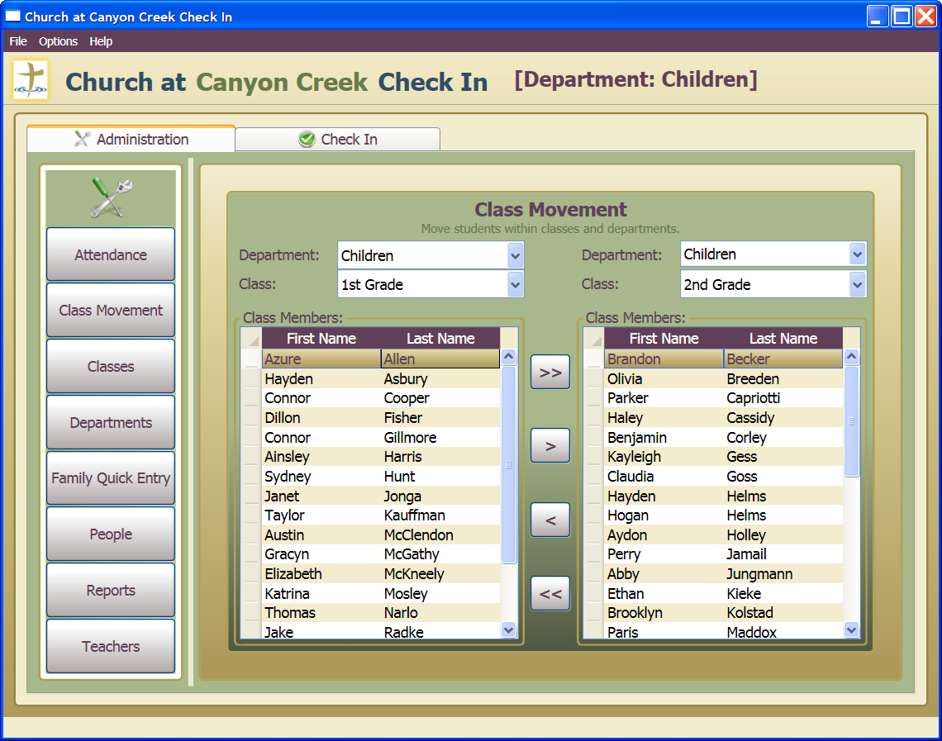

### Moving all members of a class within department or to new department

1. Select a Department and Class on the LEFT. The Department combo box will default to the currently configured department for the application.
2. Select a Department and Class on the RIGHT. The Department combo box will default to the currently configured department for the application.
3. Press the button to move ALL class members from the class on the LEFT to the class on the RIGHT.



or

1. Press the button to move ALL class members from the class on the RIGHT to the class on the LEFT.



### Moving selected members of a class within department or to new department

1. Select a Department and Class on the LEFT. The Department combo box will default to the currently configured department for the application.
2. Select a Department and Class on the RIGHT. The Department combo box will default to the currently configured department for the application.
3. Select class members that need to be moved from either the LEFT or RIGHT class. Multiple members can be selected by holding down the <CTRL> key while clicking multiple class members with the mouse.
4. Press the button to move SELECTED class members from the class on the LEFT to the class on the RIGHT.



or

1. Press the button to move SELECTED class members from the class on the RIGHT to the class on the LEFT.



### Refreshing data within the screen

The Check-in application can be used at many different workstations at the same time and uses a shared database. Because of this, it is possible that a different user will add new information to the system that is not “seen” by the other applications by default. It is possible to retrieve this new data from the database into the current application by refreshing the current screen.

1. Press the <F5> key. This will refresh the data in the current screen using the latest data from the database.

## Classes Administration

### Screen description

This screen can be used to view, add, update and delete classes.

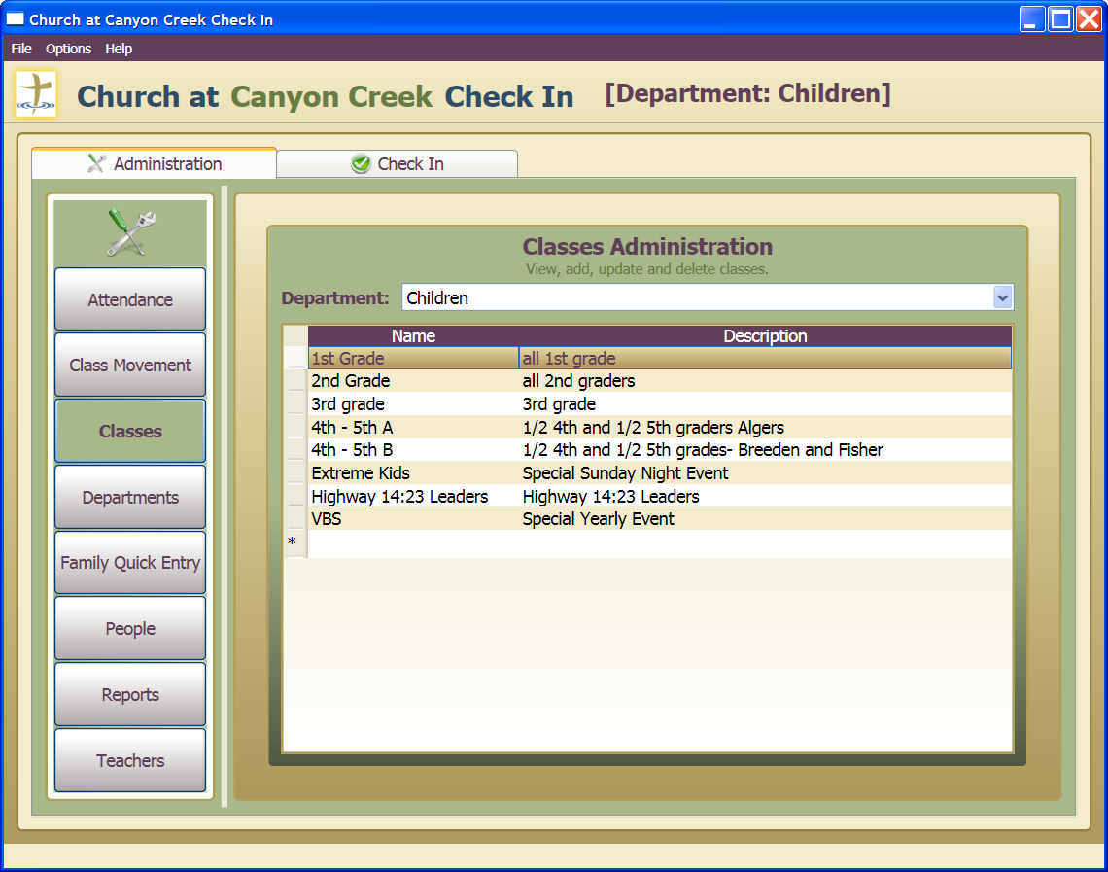

### Viewing classes within a department

1. Select the Department. The Department combo box will default to the currently configured department for the application.
2. Class within the selected Department will be displayed in the data grid.

### Adding a class to a department

1. Select the Department where new class is to be added. The Department combo box will default to the currently configured department for the application.
2. Click on the empty row at bottom of data grid which is designated with the “*” in the row header.
3. Press the <F2> key. A new class row will be added with name set to “<Enter Class Name>” and description set to “<Enter Class Description>”.
4. Press the <TAB> key once to enter the class name field. Type in a new class name.
5. Press the <TAB> key again to enter the class description field. Type in a new class description.
6. Press the <ENTER> key to save the new class or press the <ESC> key TWICE to cancel the addition of the new class.

### Updating a class within a department

1. Select the Department where class is to be updated. The Department combo box will default to the currently configured department for the application.
2. Click on the class which is to be updated.
3. Press the <F2> key. The class will enter “edit” mode.
4. Press the <TAB> key once to enter the class name field. Make any changes to class name.
5. Press the <TAB> key again to enter the class description field. Make any changes to class description.
6. Press the <ENTER> key to save the updated class or press the <ESC> key TWICE to cancel the update of the class.

### Deleting a class from a department

1. Select the Department where class is to be deleted. The Department combo box will default to the currently configured department for the application.
2. Click on the class which is to be deleted.
3. Press the <DELETE> key. A confirmation dialog will be displayed.

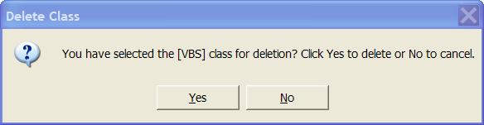

1. Click “Yes” button to delete the selected record or click “No” button to cancel deletion.

WARNING: It is not possible to delete a class that still has class members assigned to it. If an attempt is made to delete while class members are assigned, an error will occur and the user will be informed of the error in the application. Before deleting, all assigned class members will first need to be deleted or moved to other classes. When a class is deleted, all attendance records tied to that class will also be deleted.

### Refreshing data within the screen

The Check-in application can be used at many different workstations at the same time and uses a shared database. Because of this, it is possible that a different user will add new information to the system that is not “seen” by the other applications by default. It is possible to retrieve this new data from the database into the current application by refreshing the current screen.

1. Press the <F5> key. This will refresh the data in the current screen using the latest data from the database.

## Departments Administration

### Screen description

This screen can be used to view, add, update and delete departments and classes assigned to department.

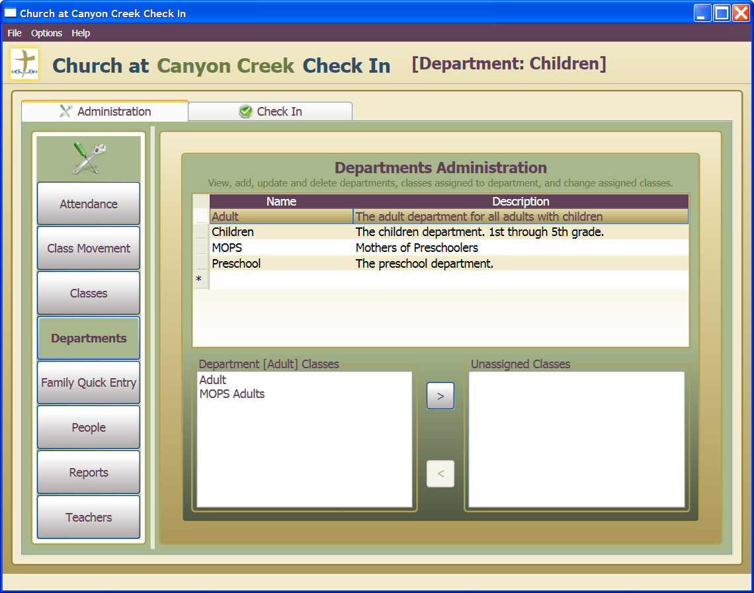

### Viewing departments

1. All departments currently in the system are displayed in the upper data grid.
2. Selecting a department will cause the currently assigned classes to be displayed in the bottom left list box.

### Adding a department

1. Click on the empty row at bottom of data grid which is designated with the “*” in the row header.
2. Press the <F2> key. A new department row will be added with name set to “<Enter Department Name>” and description set to “<Enter Department Description>”.
3. Press the <TAB> key once to enter the department name field. Type in a new department name.
4. Press the <TAB> key again to enter the department description field. Type in a new department description.
5. Press the <ENTER> key to save the new department or press the <ESC> key TWICE to cancel the addition of the new department.

### Updating a department

1. Click on the department which is to be updated.
2. Press the <F2> key. The department will enter “edit” mode.
3. Press the <TAB> key once to enter the department name field. Make any changes to department name.
4. Press the <TAB> key again to enter the department description field. Make any changes to department description.
5. Press the <ENTER> key to save the updated department or press the <ESC> key TWICE to cancel the update of the department.

### Deleting a department

1. Click on the department which is to be deleted.
2. Press the <DELETE> key. A confirmation dialog will be displayed.

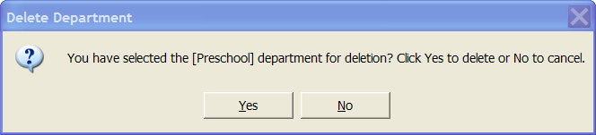

1. Click “Yes” button to delete the selected record or click “No” button to cancel deletion.

WARNING: It is not possible to delete a department that still has classes assigned to it. If an attempt is made to delete while classes are assigned, an error will occur and the user will be informed of the error in the application. Before deleting, all assigned classes will first need to be deleted or moved to other departments.

### Assigning classes to a department

1. Click on the department where classes need to be assigned.
2. Currently assigned classes will be shown in bottom left list box. Use buttons to assign selected classes to the department or to remove assigned classes to unassigned list.

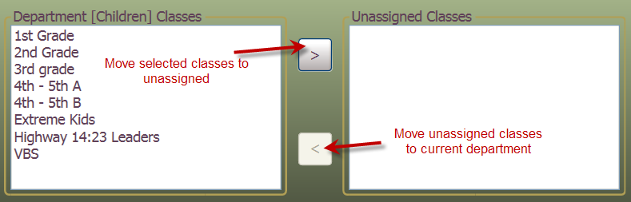

### Refreshing data within the screen

The Check-in application can be used at many different workstations at the same time and uses a shared database. Because of this, it is possible that a different user will add new information to the system that is not “seen” by the other applications by default. It is possible to retrieve this new data from the database into the current application by refreshing the current screen.

1. Press the <F5> key. This will refresh the data in the current screen using the latest data from the database.

## Family Quick Entry

### Screen description

This screen can be used to add family members, assign them to appropriate departments and classes and check them in along with printing their [name tags](#Name Tag Label Formats). This screen is only meant to be used when ADDING new people to the system.

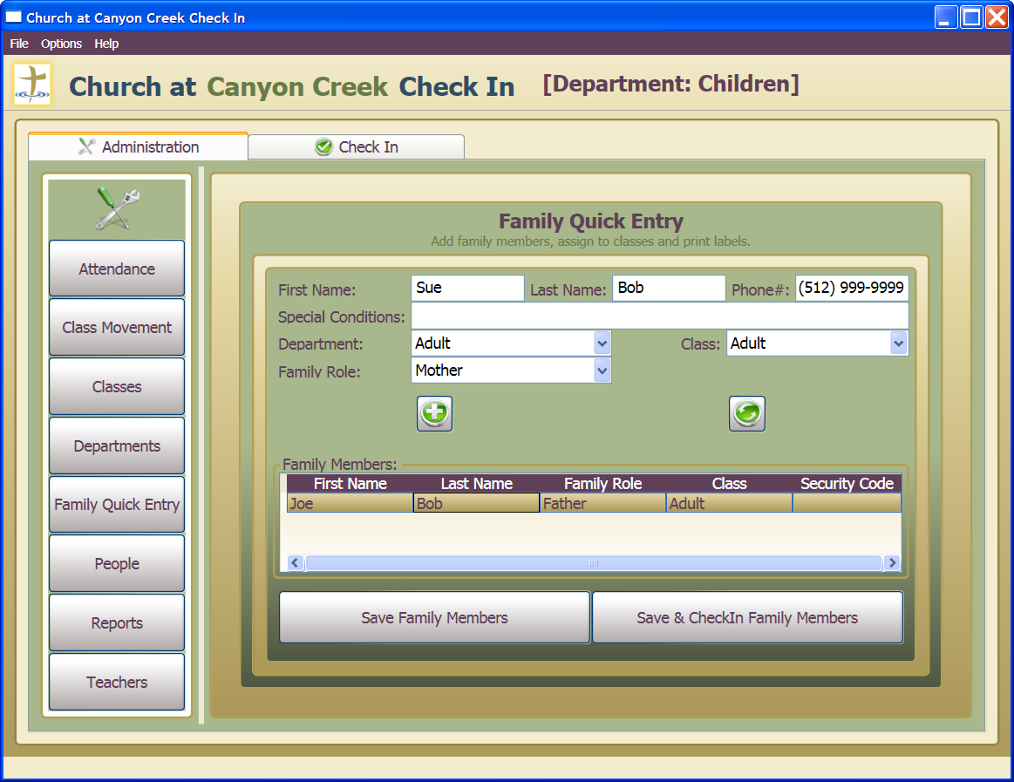

### Adding a person to the family members list

1. Enter the First Name, Last Name, Phone Number and Special Conditions (if applicable) of the new person. Select the appropriate Department, Class and Family Role for the new person.
2. Click the add family member button.



1. The person will be added to the “Family Members” list.

### Edit a person in the family members list

1. After a person has been added to the “Family Members” list, the person’s information can be updated by selecting the person in the list. When selected, the current information for that person will be displayed.
2. Make any edits to the person’s information as desired.
3. Click the refresh family member button.



### Saving family members

1. Add ALL family members to the “Family Members” list.
2. Click the “Save Family Members” button. All family members will be saved to the database BUT NOT CHECKED IN.
3. After saving, an acknowledgement message will be displayed. Click the “OK” button to acknowledge the save. This will clear the screen and ready it for entering a new family if desired.

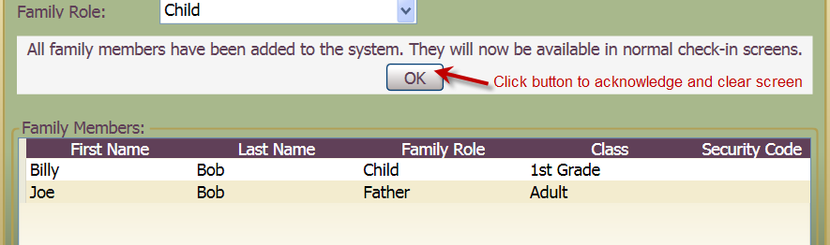

### Saving and checking in family members

1. Add ALL family members to the “Family Members” list.
2. Click the “Save & CheckIn Family Members” button. All family members will be saved to the database, checked in to their respective classes and name-tag labels will be printed for each person. Security codes will be added to the “Family Members” list as each person is checked in.
3. After saving, an acknowledgement message will be displayed. Click the “OK” button to acknowledge the save. This will clear the screen and ready it for entering a new family if desired.



### Refreshing data within the screen

The Check-in application can be used at many different workstations at the same time and uses a shared database. Because of this, it is possible that a different user will add new information to the system that is not “seen” by the other applications by default. It is possible to retrieve this new data from the database into the current application by refreshing the current screen.

1. Press the <F5> key. This will refresh the data in the current screen using the latest data from the database.

## People Administration

### Screen description

This screen can be used to view, add, update and delete people and assign them to the appropriate department and class. People can also be grouped into families.

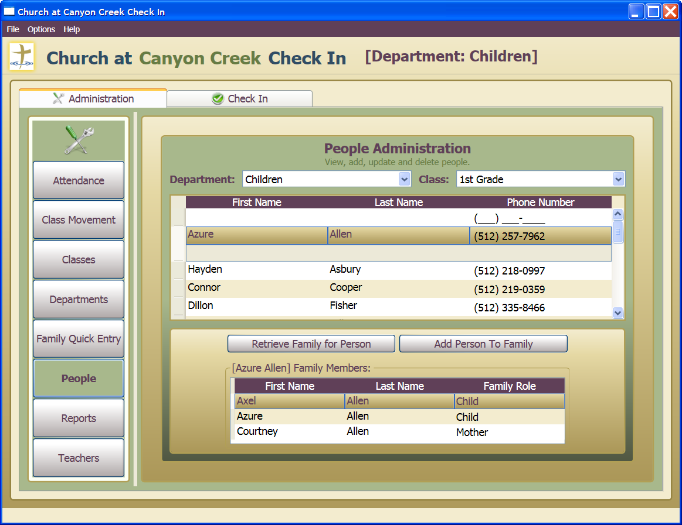

### Viewing class members

1. Select the department and class. The Department combo box will default to the currently configured department for the application.
2. Members of the selected class will be shown in the data grid.

### Adding a new class member

1. Select the department and class where the new person is to be added. The Department combo box will default to the currently configured department for the application.

**NOTE**: If a person is added to the wrong department and class, you can use the Class Movement screen to place them in the correct class.

1. Click on the empty row at **top** of data grid which is designated with the “*” in the row header.
2. Press the <F2> key. A new person row will be added with first name set to “<Enter First Name>” and last name set to “<Enter Last Name>”.
3. Press the <TAB> key once to enter the first name field. Type in a new first name.
4. Press the <TAB> key again to enter the last name field. Type in a new last name.
5. Press the <TAB> key again **twice** to enter the phone number field. Type in a phone number.
6. Press the <TAB> key again to enter the special conditions field. Type in any special conditions.
7. Press the <ENTER> key to save the new person or press the <ESC> key TWICE to cancel the addition of the new person.

### Updating a class member

1. Select the department and class where the person is to be updated. The Department combo box will default to the currently configured department for the application.
2. Click on the specific person in the data grid.
3. Press the <F2> key. The person will enter “edit” mode.
4. Press the <TAB> key once to enter the first name field. Make any changes to the first name.
5. Press the <TAB> key again to enter the last name field. Make any changes to the last name.
6. Press the <TAB> key again **twice** to enter the phone number field. Make any changes to the phone number.
7. Press the <TAB> key again to enter the special conditions field. Make any changes to the special conditions.
8. Press the <ENTER> key to save the updated person or press the <ESC> key TWICE to cancel the updates to the person.

### Deleting a class member

1. Select the department and class where the person is to be deleted. The Department combo box will default to the currently configured department for the application.
2. Click on the specific person in the data grid.
3. Press the <DELETE> key. A confirmation dialog will be displayed.

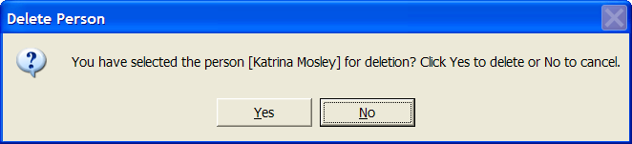

1. Click “Yes” button to delete the selected record or click “No” button to cancel deletion.

WARNING: Be aware when deleting people to not affect people which may be used in a different department. When a person is deleted, all attendance records for the person will be deleted and the person will be removed as a member from all classes.

### Moving a class member to a different class

1. Moving a class member to a different class should be done using the Class Movement screen. However, it is possible to delete the class member in this screen and add them back in a different class.

### Viewing a person’s family members

1. Select the department and class where the person is located. The Department combo box will default to the currently configured department for the application.
2. Click on the specific person in the data grid.
3. Click the “Retrieve Family For Person” button.
4. The current family members for the person will be shown in the bottom data grid.

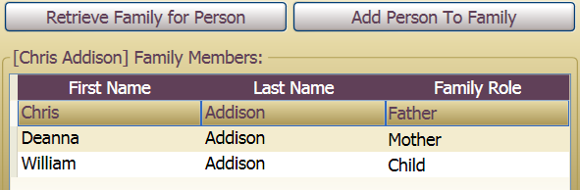

### Adding a person to an existing family

1. If the person is not already entered into the system, add the new person. This person will be person A for this discussion.
2. To add person A to an existing family, first find any other member of the family. For instance, person B.
3. Select person B and click the “Retrieve Family For Person” button. This will retrieve the family members for person B.
4. Go back to person A and select them, the Family Members data grid will continue to show family members for person B.
5. Click the “Add Person To Family” button. This will add person A as a family member of person B.
6. Adjust family roles as appropriate.

### Deleting a person from an existing family

1. Select the department and class where the person is located. The Department combo box will default to the currently configured department for the application.
2. Click on the specific person in the data grid.
3. Click the “Retrieve Family For Person” button.
4. The current family members for the person will be shown in the bottom data grid.
5. Select the person to remove from the “Family Members” data grid.
6. Press the <DELETE> key. A confirmation dialog will be displayed.

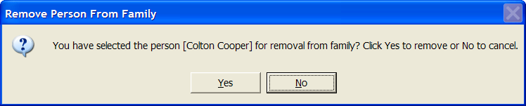

1. Click “Yes” button to delete the selected record or click “No” button to cancel deletion.

### Updating family roles for an existing family

1. Select the department and class where the person is located. The Department combo box will default to the currently configured department for the application.
2. Click on the specific person in the data grid.
3. Click the “Retrieve Family For Person” button.
4. The current family members for the person will be shown in the bottom data grid.
5. To adjust the family role for a person in the family, select that person from the Family Members list and press the <F2> key. The combo box with family roles will enter edit mode and allow a different selection.

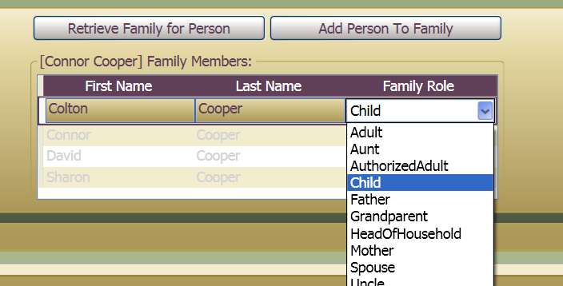

1. Select the appropriate family role.
2. Press the <ENTER> key to save the updated family role or press the <ESC> key TWICE to cancel the updates to the person’s family role.

### Refreshing data within the screen

The Check-in application can be used at many different workstations at the same time and uses a shared database. Because of this, it is possible that a different user will add new information to the system that is not “seen” by the other applications by default. It is possible to retrieve this new data from the database into the current application by refreshing the current screen.

1. Press the <F5> key. This will refresh the data in the current screen using the latest data from the database.

## Reports Administration

### Screen description

This screen can be used to view attendance reports or other reports available in the application. Reports can be saved as [.XPS](http://en.wikipedia.org/wiki/XML_Paper_Specification) (XML Paper Specification) documents or printed. The XPS standard specifies a set of document layout functionality for paged, printable documents. After saving, these .XPS documents can be opened by double-clicking on the file which should open it in Internet Explorer.

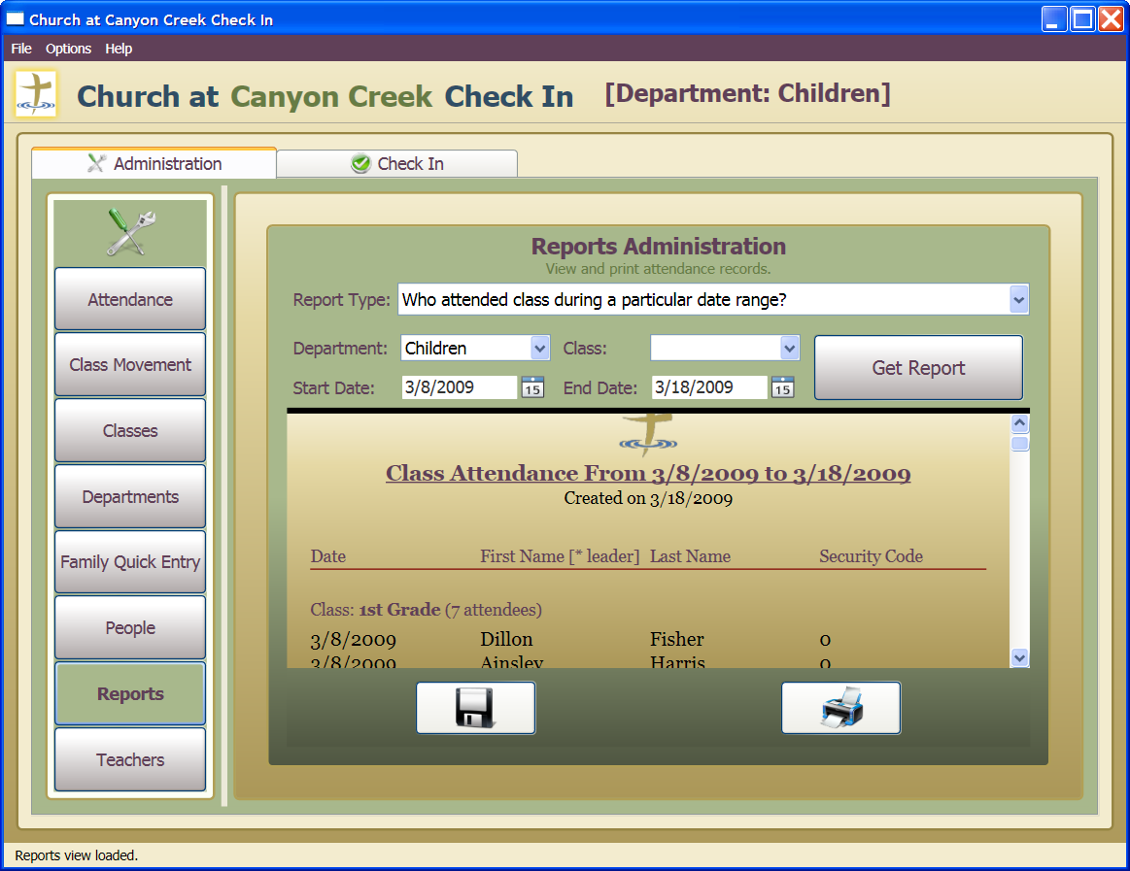

### Reporting on who attended class during a particular date range

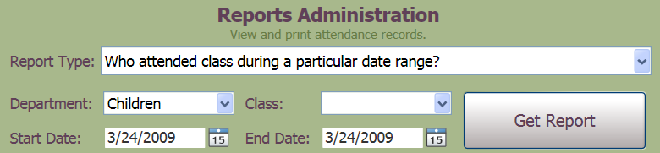

1. Select Report Type “Who attended class during a particular date range?”.
2. Select the desired Department. The department that the check-in application is configured for will be the default department.
3. To get attendance records for all classes, leave the Class combo box empty. To get attendance for a specific class, select it in the Class combo box.
4. Select the desired Start Date and End Date.
5. Click the “Get Report” button.
6. A report will be generated for the selected department and class(es) during the specified date range. Classes will be sorted in ascending order. Attendance records will be sorted by Date, then Last Name and finally First Name.

### Reporting on how many people attended a class during a particular date range

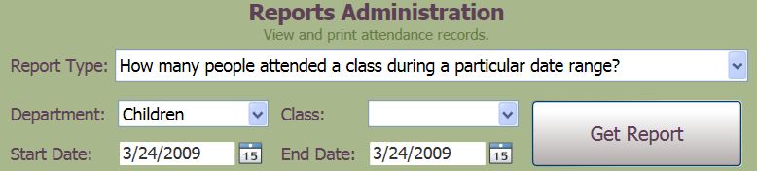

1. Select Report Type “How many people attended a class during a particular date range?”.
2. Select the desired Department. The department that the check-in application is configured for will be the default department.
3. To get attendance records for all classes, leave the Class combo box empty. To get attendance for a specific class, select it in the Class combo box.
4. Select the desired Start Date and End Date.
5. Click the “Get Report” button.
6. A report will be generated for the selected department and class(es) during the specified date range. Classes will be sorted in ascending order. Attendance records will be sorted by Date.

### Reporting on the attendance record for a particular person

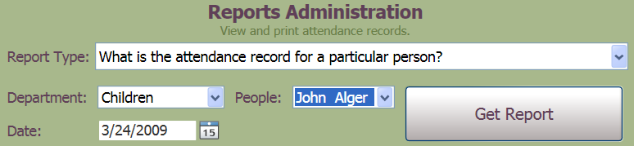

1. Select Report Type “What is the attendance record for a particular person?”.
2. Select the desired Department. The department that the check-in application is configured for will be the default department.
3. Select the person to get attendance records for by selecting the name in the People combo box.
4. Select the desired Date. When a date is selected, the person will only show if the selected person attended on that date. To retrieve ALL attendance records for the selected person, highlight the date and delete it. The Date window will display “Show Calendar”.
5. Click the “Get Report” button.
6. A report will be generated for the selected department and person limited by date if specified. Attendance records will be sorted by Date and Class.

### Saving a report as a .XPS (XML Paper Specification) document

1. Choose the report and retrieve it using the “Get Report” button.
2. Click the Save Report button.



1. A “Save the Report to File” dialog will be shown. Select the location where report is to be saved. Give the report a name and then click the “Save” button. The report will be saved as a .XPS (XML Paper Specification) document.

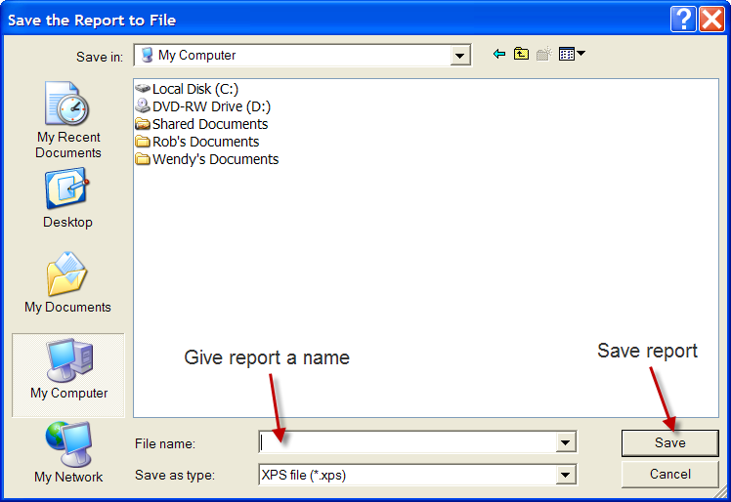

### Printing a report

1. Choose the report and retrieve it using the “Get Report” button.
2. Click the Print Report button.



1. A “Print” dialog will be shown. Select the correct printer where the report is to be printed. Set any other options desired for printing and then click the “Print” button. The report will be printed on the selected printer.

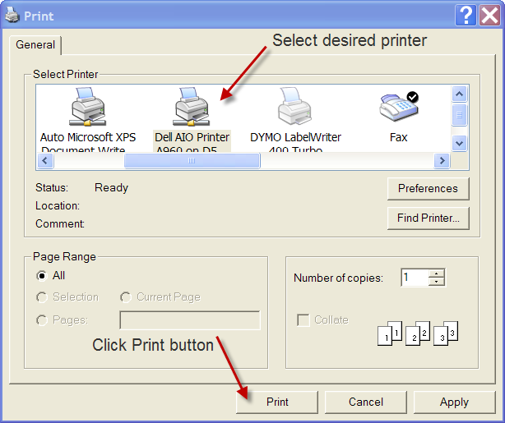

### Refreshing data within the screen

The Check-in application can be used at many different workstations at the same time and uses a shared database. Because of this, it is possible that a different user will add new information to the system that is not “seen” by the other applications by default. It is possible to retrieve this new data from the database into the current application by refreshing the current screen.

1. Press the <F5> key. This will refresh the data in the current screen using the latest data from the database.

## Teachers Administration

### Screen description

This screen is used to view, add and delete class teachers. Name tags for teachers can also be printed using this screen.

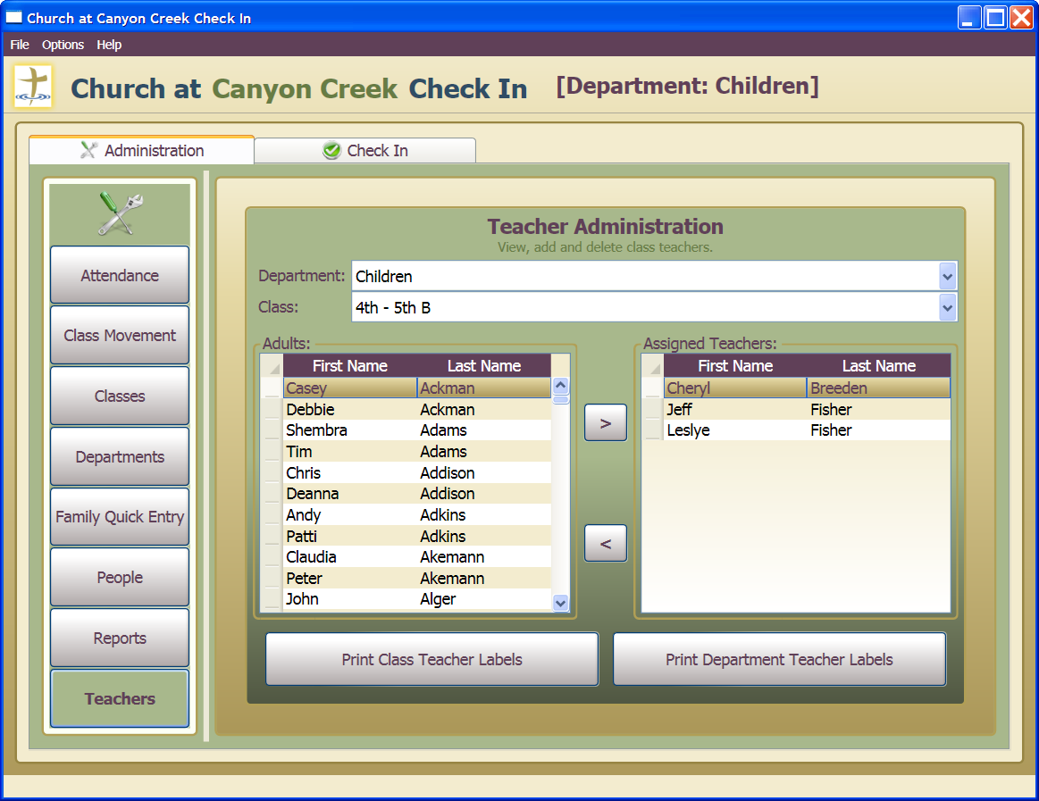

### Adding an adult as a teacher of a class

1. Select the correct department and class where the teacher is to be assigned. The department that the check-in application is configured for will be the default department.
2. Select the adult whose is to be assigned as teacher from the list of adults.

**NOTE:** The list of adults in the “Adults” list is all adults in the “Adult” department and the “Adult” class. If the check-in application is configured for the “MOPS” department, then the adults in the list is all adults in the “Adult” department and the “MOPS Adults” class.

1. Click the “>” button to move the adult to the selected class as an assigned teacher.

### Removing an adult as a teacher from a class

1. Select the correct department and class where the teacher is assigned. The department that the check-in application is configured for will be the default department.
2. Select the adult who is assigned as a teacher from the list of assigned teachers.
3. Click the “<” button to remove the adult as an assigned teacher from the selected class.

### Printing teacher labels for a class

1. Select the correct department and class for which teacher labels are to be printed. The department that the check-in application is configured for will be the default department.
2. Click the “Print Class Teacher Labels” button to print a teacher label for each teacher in the selected class.

### Printing teacher labels for a department (all classes)

1. Select the correct department for which teacher labels are to be printed. The department that the check-in application is configured for will be the default department. It does not matter which class is selected.
2. Click the “Print Department Teacher Labels” button to print a [teacher label](#Name Tag Label for Teacher) for each teacher in every class in the selected department.

### Refreshing data within the screen

The Check-in application can be used at many different workstations at the same time and uses a shared database. Because of this, it is possible that a different user will add new information to the system that is not “seen” by the other applications by default. It is possible to retrieve this new data from the database into the current application by refreshing the current screen.

1. Press the <F5> key. This will refresh the data in the current screen using the latest data from the database.

# Technical Information

This section focuses on various technical aspects of the check-in application. General users will most likely not be interested in this information.

## Application Installation

The Check-In application uses [Microsoft ClickOnce](http://en.wikipedia.org/wiki/ClickOnce) technology for deploying the application. ClickOnce is a Microsoft technology for deploying Windows Forms or Windows Presentation Foundation-based software, also called Smart clients.

Installation can be accomplished by following the steps outlined here.

1. The Check-In application is located on the CACCSERVER. Open share at \\CACCSERVER\CACCCheckInClient.

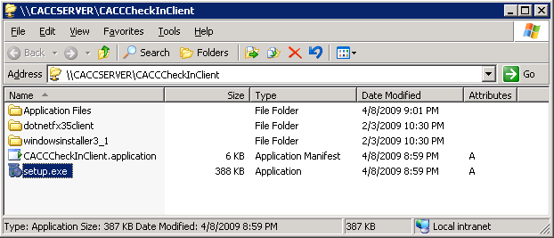

1. Run the setup.exe executable. The Check-In application has two prerequisites that must be installed first before the application can run. These are (1) .NET Framework 4.5.2 and (2) Windows Installer 4.5. The setup.exe executable will look for the prerequisites on the local system and install them if necessary.
2. A EULA (End User License Agreement) window may be shown for the .NET Framework. Accept the EULA if shown.

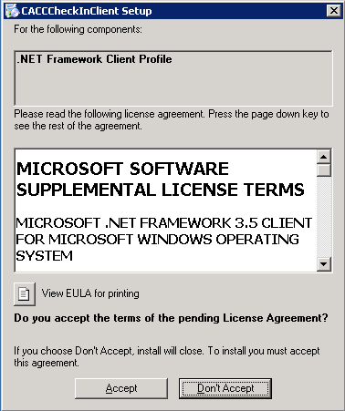

1. An application install security warning dialog will be displayed. This is because the application is published by an unofficial publisher. Just click the “Install” button to acknowledge the warning.

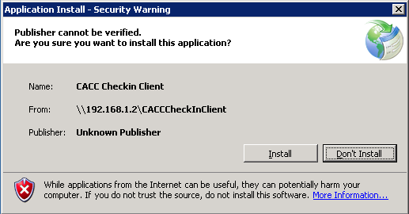

1. The Check-In application will be installed. An application icon will be displayed on the desktop which can be used to launch the application in the future.

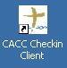

## Application Update

The Check-In application uses [Microsoft ClickOnce](http://en.wikipedia.org/wiki/ClickOnce) technology for updating the application. ClickOnce is a Microsoft technology for deploying Windows Forms or Windows Presentation Foundation-based software, also called Smart clients.

1. Every time the application is launched, it first queries the deployment server to see if any application updates are available. While this is happening, the following dialog will be displayed.

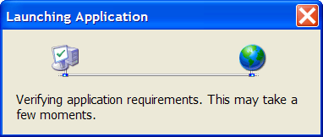

1. If there is an update available, the “Update Available” dialog will be shown.

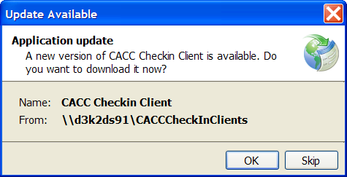

* 1. To accept the update, click the “OK” button. The updated application will be downloaded and then the application will start.
  2. To skip the update, click the “Skip” button. The existing version of the application will start.

## Application Removal

The Check-In application can be removed using the standard Control Panel applet “Add or Remove Programs”.

1. Open the “Add or Remove Programs” applet and select the entry for “CACC Checkin Client”.

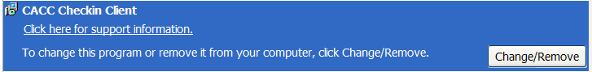

1. Click the “Change/Remove” button. The CACC CheckIn Client Maintenance dialog will be shown.

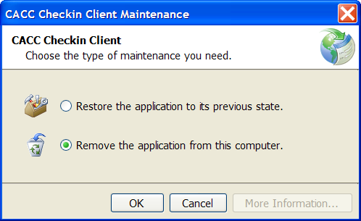

1. Select option to remove the application and click the “OK” button. (To cancel removal, click the “Cancel” button.)
2. The application will be removed from the workstation.

## The CACCCheckIn Database

The database used by the CACCCheckIn application was designed with SQL Server 2014 Express Edition. This is a free database engine available from Microsoft. SQL Server 2014 is a very robust and feature-rich database engine.

The database tables are described here along with a diagram showing the relationships between the database tables:

* People : Contains all the people used in all the supported departments and classes. This includes adults and children.
* FamilyRole : Contains the valid family roles for a person in the People table.
* ClassRole: Contains the valid class roles for a class member in the ClassMember table.
* ClassMember : Contains all the class members of each Class. A person in the People table can be a member of multiple classes. There are multiple class members for each Class.
* Attendance : Contains a list of all the attendance records for each person and class. There can be many attendance records for each person and each class.
* Class : Contains all the classes for all departments. Each department can have many classes.
* Department : Contains all the departments supported by the application.

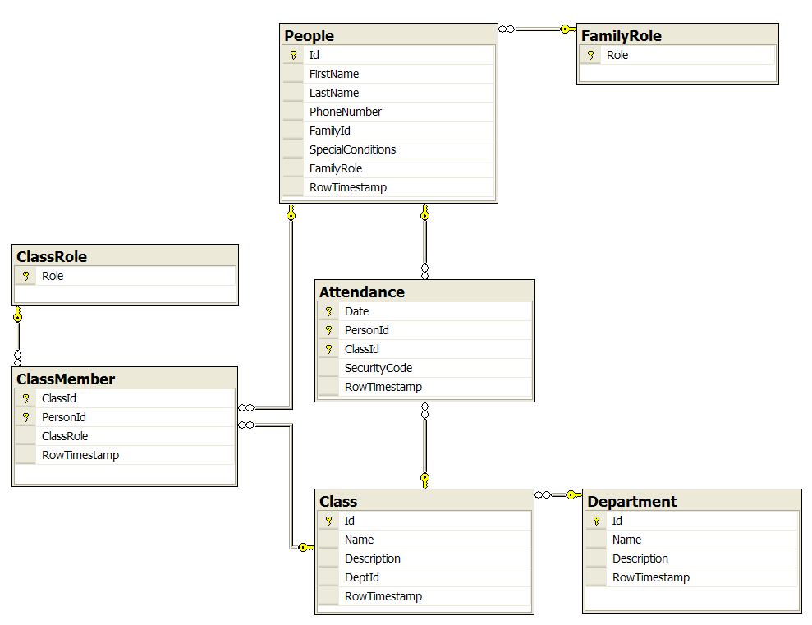

## Technology Used

The technologies chosen while designing the check-in application are listed below.

* Microsoft Visual Studio Community 2013: [<http://www.visualstudio.com/en-US/products/visual-studio-community-vs>]
  + This is a FREE product from Microsoft.
  + Compiled to target .NET Framework 4.5.2
  + The check-in application is designed with Windows Presentation Framework (WPF) and the check-in service is designed with Windows Communication Framework (WCF).
* Microsoft SQL Server 2014 Express: [<http://www.microsoft.com/en-us/server-cloud/Products/sql-server-editions/sql-server-express.aspx>]
* Composite Application Guidance for WPF 2008 – July 2008 Edition [<http://compositewpf.codeplex.com/Release/ProjectReleases.aspx?ReleaseId=14975>]
* WPF Toolkit - January 2009 Release [<http://wpf.codeplex.com/Release/ProjectReleases.aspx?ReleaseId=22567>]
* WPF Transitionals v1.2 [<http://www.codeplex.com/transitionals>]
* Seiko Instrument's Smart Label Printer (SLP) Software Developer Kit (SDK) version 7.1 [<http://labelprinters.sii-thermalprinters.com/t/Support%20Software%20and%20Driver%20Downloads>]
* DYMO Label Software Application Version 7.8 [<https://global.dymo.com/enUS/RNW/RNW.html?pg=std_adp.php&p_faqid=101>]

## Source Code Repository

Source code for the CACC Check-In application is stored at the Google Code Subversion Repository [<https://cacc-checkin.googlecode.com/svn/trunk>] and GitHub [<https://github.com/robert-wayne-smith/cacc-checkin>]

## Physical Layout Diagram

The following diagram depicts how the check-in stations in both the Preschool/MOPS and Children’s departments communicate with the database on the server.

**NOTE**: As of January 29, 2015, the service is updated to .NET 4.5.2 WCF Service and running on SQL Server 2014, but can still run on older SQL Server versions and Express editions.

